Winkey
Winkey’s WebService
Documentation on the WebServices
Boris Andrzejczak/Lydia Roustan
20/08/2010

Table of Contents
1. Overview 4
1.1 Purpose 4
1.2 Sphere of application 4
1.3 References of different documents of the Winkey product 4
2. Overview 5
2.1 Supported OS 5
2.2 Architecture of the WebService 5
2.2.1 Function 5
2.2.2 CurrentStructure: 5
3. Installation and Configuration of the Webservice 6
3.1 Installation 6
3.2 Configuration 6
3.3 Introduction to call functions 7
3.3.1 Structure of APIs 7
3.3.2 Availability of these APIs 8
3.3.3 APIs according to the access control sub-program. 9
4. Integration 9
4.1 Description of different APIs to call 9
4.1.1 TestAccess: 9
4.1.2 GetVersion 10
4.1.3 ControlKey: 11
4.1.4 GetListTypeCA: 14
4.1.5 GetListSite: 15
4.1.6 GetListKey: 16
4.1.7 GetListAction 17
4.1.8 GetListLock 18
4.1.9 GetListTransaction: 19
4.1.10 GetListFunction: 20
4.1.11 ControlActionSingle 21
4.2 The parameters 22
4.2.1 IdTypeCA 22
4.2.2 TypeAccesCA 23
4.2.3 IdSite 24
4.2.4 IdKeyLock 25
4.2.5 IdAction 26
ControlActionSingle 27
ControlKey 27
4.2.6 Option/DataOption 28
5. Examples 29
6. APPENDICES 30
6.1 Appendix1: Structure of functions 30
6.1.1 Structure of the Access control function 30
6.1.2 Structure of the function ListTypeCA 33
6.1.3 Structure of the function ListSite 34
6.1.4 Structure of the function ListAction 35
6.1.5 Structure of the function ListKey 36
6.1.6 Structure of the function ListFunction 38
6.1.7 Structure of the function ListLock 39
6.1.8 Structure of the function ControlActionSingle 40
6.1.9 Structure of the function ListTransaction 42
6.2 Annexe 2 : Using de KabaAppliTest 44



Overview

Purpose

The purpose of this documentation is to explain how to connect to Winkey’s WebService, in order to access its different functions (management of different access controls, calculation, deleting codes, encoding cards,etc…..,)

Sphere of application

These specifications are required for any client application having to connect to the Winkey code server via the Winkey WebService.

References of different documents of the Winkey product

How to install Winkey: FR_P-502-A_Installation de Winkey en client-serveur-416.pdf
How to set the parameters for Winkey: FR_ParametrageWinkey_Version-4.16_2009-07-C.pdf
How to configure the Winkey database: FR_WinkeyInitialize_Version-4.13_2006-03-C.pdf
How to use Winkey: FR_Winkey_DocumentUtilisateur_Version4.13_2008-B.pdf

Overview

Supported OS

Supported OS:
- XP
- Seven (not tested)
- Vista (not tested)

Architecture of the WebService

Function
The WebService functions as a "router" redirecting and transcribing the requests onto the called access control program.
There is currently no notion of security on the WebService

CurrentStructure:

Installation and Configuration of the Webservice

Installation

- Launch Winkey Installer
- Select Custom Installation

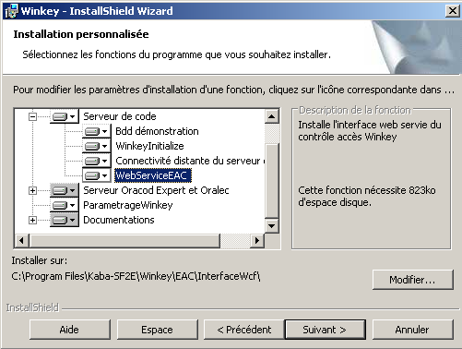
- Install the WebServiceEAC

Configuration

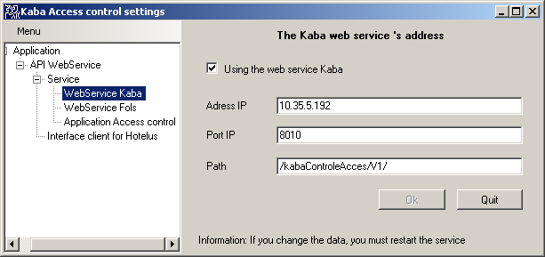 | launch KabaParametrageWebService.exe  - Go to the node WebServer Kaba  - Check "using the web Servida Kaba"  - Enter the TCP / IP address of your network  - Enter a free port on your machine hine (if port 8010 is not used: choose)  - Save by clicking "OK"
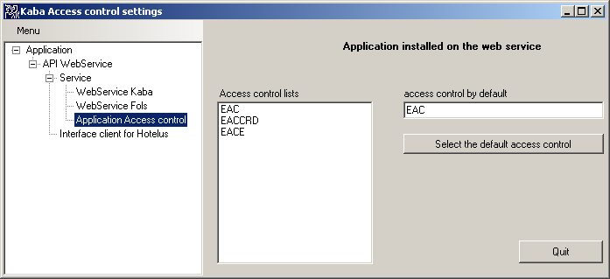 | If multiple access control software have been installed on your machine: Please select one default  - Go to the node "Application access control"  - Select an access control list "Access control lists"  - Click on "Select the default access control"
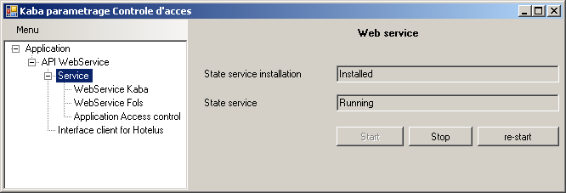 | - Go to the node "service" under the node "Web service API"  - Start or re démmarrer service

Introduction to call functions

Structure of APIs
Certain APIs may be called using 2 different structures.

- Either by reference: not yet available for most APIs
E.g.:
int ControlActionSingle2(string User, string Pwd, ref string IdTypeCA, ref string IdSite, string IdAction, int Synchrone,ref string Location, ref string[] Option, ref string[] DataOption, ref string Data, ref int StateTransaction, out string[] ListStateTransaction);

- Or by Object: All the structures of different objects are available in appendix
E.g.:
StructureControlActionSingle ControlActionSingle(StructureControlActionSingle Data);
The operation, of these 2 functions, is identical

Availability of these APIs
Several APIs are there to send the different requests to the Winkey server via the WebService.
These APIs are independent of the access control installed on the site.
APIs | Description | Availability compared to type of structure of the function
TestAccess | Function enabling indication of whether one is actually connected to the WebService | Available
GetVersion | Function enabling indication of version of WebService | Available
ControlKey  ControlKey2 | Function allowing user to calculate, delete, supply a code, ...,encode a card | Structure Object: Available  Structure Reference: Available
ControlActionSingle  ControlActionSingle2 | Non-generic function not concerning code calculation | Structure Object: Available  Structure Reference: Future
GetListTypeCA  GetListTypeCA2 | Function allowing knowledge of list of programs formanagement of different access controls (by code, by carte, on-line, etc …..) | Structure Object: Available  Structure Reference: Future
GetListSite  GetListSite2 | Function allowing retrieval of the name of the BDDs of different sites of the selected access control | Structure Object: Available  Structure Reference: Available
GetListKey:  GetListKey2 | Function allowing retrieval of the room keys according to the program for management of the selected access control and the selected database | Structure Object: Available  Structure Reference: Available
GetListAction  GetListAction2 | Function allowing retrieval of the various possibleactions according to the program for management of the selected access control and the selected database | Structure Object: Available  Structure Reference: Available
GetListFunction  GetListFunction2 | Function allowing retrieval of the list of APIs from the WebService | Structure Object: Available  Structure Reference: Future
GetListLock  GetListLock2 | Function allowing retrieval of the locks according to the program for management of the selected access control and the selected database | Structure Object: Available  Structure Reference: Future
GetListTransaction  GetListTransaction2 | Function enabling retrieval of the list of transactions according to a given key | Structure Object: Available *  Structure Reference: Available *  * incomplete

APIs according to the access control sub-program.

Imp = does not compute
X = Ok
Futur = later

Access control : names on the parameter "IdTypeCA" | EAC | EACE | EACCRD
Type of access control:  lock: | Code  Oracod, Codacod, Clavotel, Codela, 610, 660 E/F/K/M/W | Code  Oracod Expert (on line) | Card  710, 760, 790
Undercoat software | Winkey | Winkey (with Oracod Expert) | WinCarte
ControlKey | GETKEY DELKEY DELCODE CURENTKEY FUTURKEY | WRITECODE DELETECODE | GETKEY  CURENTKEY
ControlActionSingle | No function | X (DELETEADROE) | -
GetListTypeCA | X | X | x
GetListSite | X | X | -
GetListKey | X (key) | Imp (lock) | -
GetListAction | X | X | x
GetListFunction | X | X | x
GetListLock | futur | - | -
GetListTransaction | X | - | -

Integration

Description of different APIs to call

TestAccess:
Function enabling user to test connection to WebService.
int TestAccess();

Return of the command Values Comment
Back 1 If the client application is in fact connected to the WebService

GetVersion
Function enabling indication of version of WebService
int GetVersion(ref string lVersion);
Command setting Value IN/OUT Comment
lVersion string OUT Returns the version of the Webservice

ControlKey:
Function allowing one, according to the programme for managementof access control, the site, and the lock, to calculate, retrieve, delete(………) a code

2 syntaxes:
- int ControlKey2(string User, string Pwd, ref string IdTypeCA, ref string IdSite, string IdAction,int NbAction, ref string[] IdKeyLock, string UserLocal, ref string Location, string RefTransaction, ref DateTime DateStart, ref DateTime DateEnd, int Synchrone, ref string[] Option, ref string[] DataOption, ref string InformationDisplay, ref string DataReturn,ref int StateTransaction, ref string[] ListStateTransaction);
- StructureControlAcces ControlKey(StructureControlAcces Data):
The structure StructureControlAcces is supplied in the appendix
*: The parameters with * may be retrieved by calling other functions

Command setting
Command setting Value IN/OUT Comment
User string IN User
Pwd string IN User password
IdTypeCA * string IN/OUT(Default) Type of program managing access control of the site. (If not supplied the setting is sent back with the value as that defined by default)
IdSite * string IN/OUT(Default) Name of the database (If not supplied the setting is sent back with the value as that defined by default)
IdAction * string IN Request to be carried out at server
NbAction integer IN Number of times to execute this request
IdKeyLock * string[] IN 2 differentnotions according to the access control: - Notion of key: (example: access control by code) - Notion of lock: (example: access control by card)
UserLocal string IN If key notion (Access control by code), parameter not used. If lock notion (Access control by card): parameter not yet defined (parameter not used for EAC or EACE)
Location string IN/OUT Name of the machine where the calling client application is located
RefTransaction string IN Unique transaction number may be equal to IdKeyLock.
If parameter not unique, it will destroy the old code
DateStart string IN/OUT Start date
DateEnd string IN/OUT End date
Synchrone integer IN Synchronous action or not
Option string[] IN/OUT Options Examples date format – see Paragraph: 4.2.6
DataOption string[] IN/OUT Data about options
see Paragraph: 4.2.6
InformationDisplay string IN/OUT Information to display (ex: room code)
DataReturn string OUT/IN Function feedback data
StateTransaction integer OUT Error feedback
ListStateTransaction string[] OUT List of all errors

The parameters of the API ControlKey according to sub-programs of the access control (EAC, EACE).
For the access controls EAC and EACE, the parameters defined by:
- A P: are compulsory parameters to be imposed
- A value: are parameters used but imposed by the application
  - 1 for true
  - 0 for false
- A -: are parameters not used, not compulsory

Paramètres | Logiciel gestion des Contrôles d’accès A codes | Logiciel gestion des Contrôles d’accès On Line | Logiciel gestion des Contrôles d’accès On card
User (string :in) | P | P | P
PWD (string :in) | P | P | P
IdTypeCA (string :in-out(default)) :  Type de Logiciel de gestion du contrôle accès : | EAC | EACE | EACCRD
IdSite (string : in-out)  Site-Domaine-BDD : | P | P | -
IdKeyLock (string :in)  Clef-User-Serrure | P (key) | P (lock) | P (lock)
IdAction (string :in)  Action : | P | P | P
Nb Action (int : in-out) |  |  | P
Location (string :in-out) |  |  | P
Ref Transaction (string :in-out) | P(in) | P(in) | -
DateStart Heure Début (DateTime :in-out) | P | P | P
DateEnd (DateTime :in-out) | P | P | P
Synchrone (int :in) (0 non, 1 oui) | 1 | 0 | 1
Option [Nb] (string :in-out) | P | P | P
Data Option [Nb] (string :in-out) | P | P | P
Information Display (string :in-out) | P(out) |  | P
Data (string :in-out) | P(out) | P(in) | -
StateTransaction (int : out) | P | P | P
ListStateTransaction (string : Out ) | P | P | P

GetListTypeCA:
Function allowing retrieval of the list of the access control management program

2 syntaxes:
- int GetListTypeCA2(string User, string Pwd, ref string DefaultCA, ref string[] ListIdTypeCA, ref string[] informationTypeCA, ref string[] VersionTypeCA, ref int[] TypeAccesCA);
- StructureListTypeCA GetListTypeCA(StructureListTypeCA Data);
The structure of the 2nd function is available in the appendices see StructureListTypeCA

Command setting Value IN/OUT Comment
User string IN User
Pwd string IN User password
DefaultCA string IN Access control d)efined by default
ListIdTypeCA string[] OUT Type of program managing access control installed on the site. (If not supplied the setting is sent back with the value as that defined by default)
InformationTypeCA string[] OUT Information about the type of lock
VersionTypeCA string[] OUT Access control version
TypeAccesCA Integer[] OUT depends on the access control
See Paragraph 4.2.2

GetListSite:
Function allowing retrieval of the list of different databases according to the selected access control management program
2 syntaxes:
- int GetListSite2(string User, string Pwd, ref string IdTypeCA, ref string DefaultIdSite, ref string[] ListIdSite, ref string[] informationSite);
- StructureListSite GetListSite(StructureListSite Data);
For the structure StructureListSite see in appendix

Command setting Value IN/OUT Comment
User string IN User
Pwd string IN User password
IdTypeCA string IN/OUT Type of program managing access control of the site. (If not supplied the setting is sent back with the value as that defined by default)
DefaultIdSite string OUT Name of the database defined by default
ListIdSite string[] OUT Return List of all the sites with the requested access control program
InformationSite string[] OUT Additional information on the site

GetListKey:
Function allowing retrieval of the list of keys of a program for management of access control and of a selected database
2 syntaxes:
- int GetListKey2(string User, string Pwd, ref string IdTypeCA, ref string IdSite, ref string[] ListIdKey, ref string[] ListLibKey);

- StructureListKey GetListKey (StructureListKey Data);
The structure StructureListKey is supplied in the appendix

Command setting Value IN/OUT Comment
User string IN User
Pwd string IN User password
IdTypeCA string IN/OUT Type of program managing access control of the site. (If not supplied the setting is sent back with the value as that defined by default)
IdSite string IN/OUT Name of the database (If not supplied the setting is sent back with the value as that defined by default)
ListIdKey string[] OUT List of Keys available
ListLibKey string[] OUT List of keylabels

GetListAction
Function allowing retrieval of all actions permitted on a key and a selected database
2 syntaxes :
int GetListAction2(string User, string Pwd, ref string IdTypeCA, ref string IdSite, string IdKeyLock, ref string[], ref ListAction, ref ListTypeActiointeger[],ref ListLibAction string[]);
- StructureListAction GetListAction (StructureListAction Data);GetListAction);
The structure StructureListAction is supplied in appendix)

Command setting Value IN/OUT Comment
User string IN User
Pwd string IN User password
IdTypeCA string IN/OUT Type of program managing access control of the site. (If not supplied the setting is sent back with the value as that defined by default)
IdSite string IN/OUT Name of the database (If not supplied the setting is sent back with the value as that defined by default)
IdKeyLock string IN The key or the lock for which one wishes to retrieve the list of actions
ListAction string[] OUT List of different available actions
ListTypeAction integer[] OUT Actions used on ControlKey value =1 or on ControlActionSingle value =2
ListLibAction string[] OUT List of information about theeactions

GetListLock
Function allowing retrieval of the list of different locks of a selected site
2 syntaxes:
- int GetListLock2(string User, string Pwd, ref string IdTypeCA, ref string IdSite, ref string[] ListIdLock, ref string[] ListLibLock);
- StructureListLock GetListLock(StructureListLock Data);
(The structure StructureListLock is supplied in appendix)

Command setting Value IN/OUT Comment
User string IN User
Pwd string IN User password
IdTypeCA string IN/OUT Type of program managing access control of the site. (If not supplied the setting is sent back with the value as that defined by default)
IdSite string IN/OUT Name of the database (If not supplied the setting is sent back with the value as that defined by default)
ListIdLock string[] OUT List of locks available
ListLibLock string[] OUT List of lock labels

GetListTransaction:

Function to retrieve the list of transactions. Only access control "EAC" provided this function. And it provided only a valid transaction.

Two syntaxes:
- int GetListTransaction 2(string User, string Pwd, ref string IdTypeCA, ref string IdSite, ref string[] ListIdLock, string Filter, ref string[] ListIdTransaction, ref int State;)
- StructureListTransaction GetListTransaction (StructureListTransaction Data)
(La structure StructureListTransaction est fournie en annexe)

Paramètre de la commande Valeur IN/OUT Commentaire
User string IN User
Pwd string IN pwd
IdTypeCA string IN/OUT Type of software manages the access control of the site. (If not informed the setting is returned with value than the default)
IdSite string IN/OUT Name of the database (if nothing is indicated with the parameter is returned as the value set by default)
ListIdLock string int lock or key
Filter string int currently not used
ListIdTransaction string[] OUT List of current transaction

GetListFunction:
Function allowing retrieval of the list of all the APIs available

2 syntaxes:
- int GetListFunction2(string User, string Pwd, ref string IdTypeCA, out string[] ListIdFunction, out int[] ListTypeFunction, out string[] ListLibFunction);
- StructureListFunction GetListFunction(StructureListFunction Data);
(The structure StructureListFunction is supplied in the appendix)

Command setting Value IN/OUT Comment
User string IN User
Pwd string IN User password
IdTypeCA string IN/OUT Type of program managing access control of the site. (If not supplied the setting is sent back with the value as that defined by default)
ListIdFunction string[] OUT The list ofAPIreferences available to call
ListTypeFunction integer[] OUT Functions available on this Webservice. So its value=1. Or functions available on a specific external WebService value =2. (Currently value not taken into account)
ListLibFunction string[] OUT List of information about the functions

ControlActionSingle
Generic function not concerning the access control type EAC

2 syntaxes:
- int ControlActionSingle2(string User, string Pwd, ref string IdTypeCA, ref string IdSite, string IdAction, int Synchrone,ref string Location, ref string[] Option, ref string[] DataOption, ref string Data, ref int StateTransaction, out string[] ListStateTransaction);
- StructureControlActionSingle ControlActionSingle(StructureControlActionSingle Data);
(The structure StructureControlActionSingle is supplied in appendix)

Command setting Value IN/OUT Comment
User string IN User
Pwd string IN User password
IdTypeCA * string IN/OUT Type of program managing access control of the site. (If not supplied the setting is sent back with the value as that defined by default)
IdSite * string IN/OUT Name of the database (If not supplied the setting is sent back with the value as that defined by default)
IdAction * string IN Request to be carried out at server
Synchrone integer IN Synchronous action or not
Location string IN/OUT Indicate the name or the IP address of the machine where the calling client application is located
Option string[] IN/OUT Example options if one wishes to specify the format of the start and end date
DataOption string[] IN/OUT Data about options
Data string IN/OUT Function feedback data
StateTransaction integer OUT Error feedback, 0 = OK
ListStateTransaction string[] OUT List of all errors

The parameters

The available functions include, according to the management program for access control of the site, unused setting s, it is nevertheless wise to provide for them in the structure of the client application so that the latter is able to manage the various KABA access control management programs in a totallytransparent way.

IdTypeCA
Parameter defining the access control program to call
This parameter is found in all the functions (ControlKey GetListTypeCA GetListSite GetListAction GetListKey GetListLock GetListFunction ControlActionSingle)
- This parameter is of the string type.
- It may be an entry parameter
- if it is specified in the function
- or an exit parameter(if not supplied). In this case, the parameter is returned with its values as defined by default in KabaParametrageWebService.exe
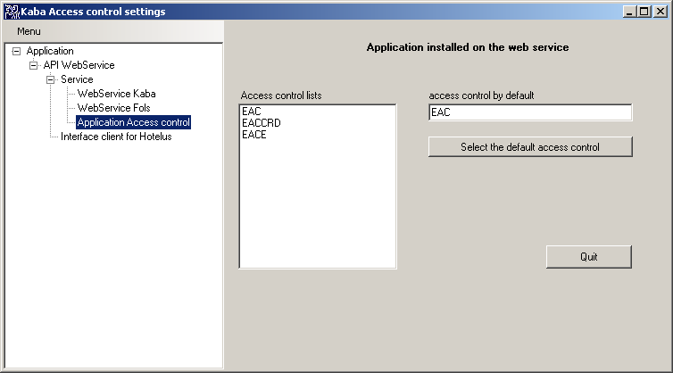

- It may have as a value:
Values |  | Comment
EAC Control program Available
access by code
EACE Control program Available
access on-line
KEY7XX Control program Future
access by card

On-line access control of the type EACE will only be managed by the WebService for very particular reasons, the latter is normally piloted by the Winkey server automatically.

TypeAccesCA
This parameter is found in the function GetListTypeCA
TypeAccesCA
- This parameter is of the integer type.
- It is an exit parameter

Values |  | Comment
0 Access control Access control by code
Notion of key
1 Access control Access control by card
Notion of lock

IdSite

On EAC : (Winkey)
Parameter defining the database of the site to call.
This parameter is found in the functions ControlKey GetListSite GetListAction GetListKey GetListLock ControlActionSingle
- This parameter is of the string type.
- It may be an entry parameter
- if it is specified in the function
- or an exit parameter ((if not supplied). In this case, the parameter is returned with its values as defined by default inWinkeyParamétrage.exe
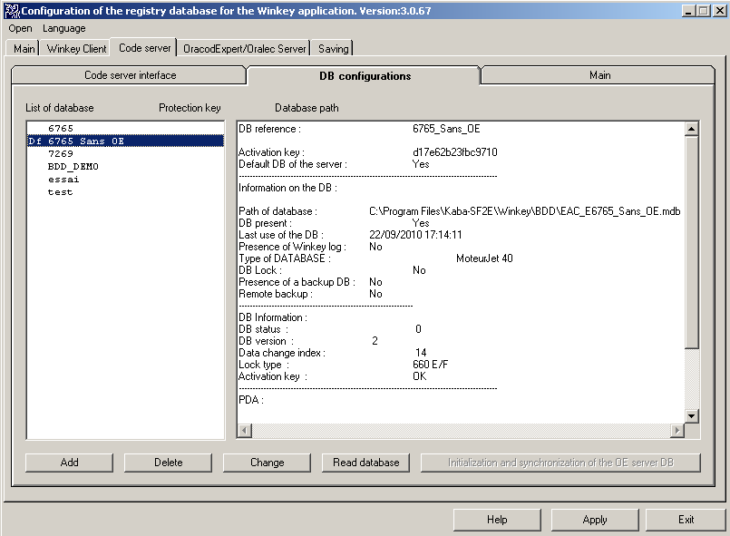

- To set the parameters for a database as default database :
- Select the database, then click on the button Change
- Or Add a new database
- The next window opens, click on Default Database:
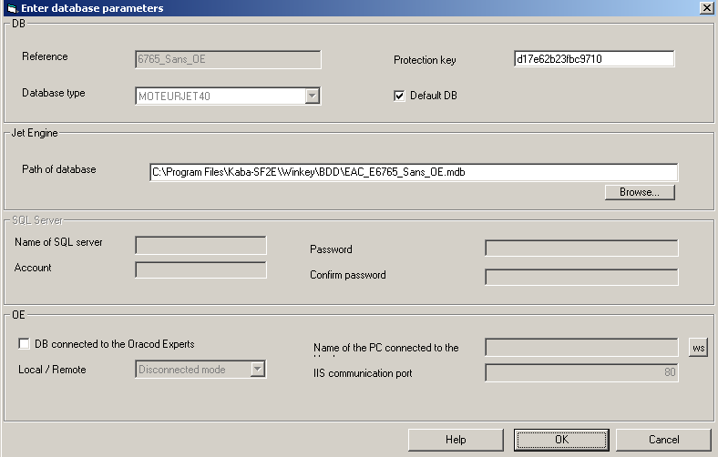

On EACE (Winkey + Oracod Expert )
There is no site management. Only one site is available at a time.
On EACCRD (Wincarte):
There is no site management. Only one site is available at a time.

IdKeyLock
This parameter is found in the functions ControlKey, GetListAction
Parameter possessing 2 notions:
- Notion of key: example: access control by code
- Notion of locks: example: access controlby card.

The function GetListTypeCA sends through the parameter ''TypeAccesCA'' if the program is managing the access controlwith the notion of key or lock

- Parameter defining the key/lock about which one wishes
- information isto be retrieved : with GetListAction
- Actions., with: ControlKey
- This parameter is a string
- Entry parameter

IdAction
Parameter defining the different actions that may be carried out on a key
This parameter is found in the functions ControlKey, GetListAction
- This parameter is a string
- This is an entryparameter (ControlKey, ControlActionSingle)

Access control sub-program | Values | Description | Comment | Via access control API
E  A  C | GETKEY | Calculation of a new code | Available | ControlKey
 | NEWKEY |  | Not Available | ControlKey
 | DELKEY | Deletes a code | Available | ControlKey
 | DELCODE | Deletes a code and supplies another which overrides the previous one | Available | ControlKey
 | CURRENTKEY | Retrieval of code in progress | Available | ControlKey
 | FUTURKEY | Calculation of a code in the future | Available. The code calculated then is not memorised. There is therefore no notion of advance | ControlKey
E  A  C  E | WRITECODE | Writes a code in the lock | Available | ControlKey
 | DELETECODE | Deletes a code in the lock | Available | ControlKey
 | DELETEADROE | Deletes all the codes of all locks | Available | ControlActionSingle
EACCRD | GETKEY  CURRENTKEY  NEWKEY  DELKEY | Encodes a new card  Encode a duplicate card *1  Accept and is equivalent to GETKEY  Accept and no n'effet. | available  available | ControlKey

Reminder the actions on the EACE type of access control are given as a guide only, as this access control is automatically piloted by the Winkey server.
*1 : Attention To duplicate a card, you must enter the same date parameter as the original card

Option/DataOption

Parameters defining the various options and their data that can be added to the command or retrieved at the end of the function
This parameter is found in the function controlKey, ControlActionSingle
- These parameters are tables ofstring. The options and the corresponding data must be on the same index of the table.
- These are either entry parameters or exit parameters
At entry, they allow, for example, the date format to be determined.
The default date format is dd/MM/yyyy HH:mm:ss, if one wishes to change it,, indicate the new desired format in DataOption

ControlKey
Ref Option = Option | Value Option = DataOption | Accessible sub-programs
FORMATDATE | Value possible =  dd/MM/yyyy HH:mm:ss (default)  MM/dd/yyyy hh:mm:ss  yyyy-MM-dd HH:mm:ss  yyMMdd HHmmss | EAC  EACE
RANGE (Compulsory) | Value from the range to send  (0 to 7) | EACE (only)

Function ControlActionSingle, None Function N’A

Examples

Several sample program and test are provided with the web service:

• KabaAppliTest.exe: to test the web service. It allows you to call any function of it. Attached is 2 information on its use.

• KabaClientControleAcces.dll: Dll for example provided with the sources for calling the web service. This dll provided in the form of callable function. Net. (Documentation \ Sample \ c # \ KabaClientControleAcces.dll)

• TestKabaClientControleAcces.exe: executable instance using the dll KabaClientControleAcces.dll to calculate codes. (Documentation \ Sample \ c # \ KabaClientControleAcces.dll)

• A sample client web service with PHP source is provided (Documentation \ Sample \ PHP)
Client of test :
KabaAppliTest.exe
Exemple de client PHP

Exemple de Client de test c#
utilisation de la technologie : C#, Vb net, COM
TestKabaClientControleAcces.exe

Exemple de Client du web service c#
KabaClientControleAcces.dll
Fourni : API .net et COM

KabaServiceControleAcces.exe (API Web Service Kaba)
C# (API 4 (B): .Net)

Serveur OE
Serveur de code Winkey
Serveur Wincarte + Fdu

APPENDICES

Appendix1: Structure of functions

Structure of the Access control function
public class StructureControlAcces
{
string _User;
string _Pwd;
string _IdTypeCA;
string _IdSite;
string _IdAction;
int _NbAction;
string[] _IdKeyLock;
string _UserLocal;
string _Location;
string _RefTransaction;
string _DateStart;
string _DateEnd;
int _Synchrone;
string[] _Option;
string[] _DataOption;
string _InformationDisplay;
string _DataReturn;
int _StateTransaction;
string[] _ListStateTransaction;

[DataMember]
public string User
{
get { return _User; }
set { _User = value; }
}

[DataMember]
public string Pwd
{
get { return _Pwd; }
set { _Pwd = value; }
}

[DataMember]
public string IdTypeCA
{
get { return _IdTypeCA; }
set { _IdTypeCA = value; }
}

[DataMember]
public string IdSite
{
get { return _IdSite; }
set { _IdSite = value; }
}
[DataMember]
public string IdAction
{
get { return _IdAction; }
set { _IdAction = value; }
}
[DataMember]
public int NbAction
{
get { return _NbAction; }
set { _NbAction = value; }
}
[DataMember]
public string[] IdKeyLock
{
get { return _IdKeyLock; }
set { _IdKeyLock = value; }
}
[DataMember]
public string UserLocal
{
get { return _UserLocal; }
set { _UserLocal = value; }
}
[DataMember]
public string Location
{
get { return _Location; }
set { _Location = value; }
}
[DataMember]
public string RefTransaction
{
get { return _RefTransaction; }
set { _RefTransaction = value; }
}
[DataMember]
public string DateStart
{
get { return _DateStart; }
set { _DateStart = value; }
}

[DataMember]
public string DateEnd
{
get { return _DateEnd; }
set { _DateEnd = value; }
}

[DataMember]
public int Synchrone
{
get { return _Synchrone; }
set { _Synchrone = value; }
}
[DataMember]
public string[] Option
{
get { return _Option; }
set { _Option = value; }
}
[DataMember]
public string[] DataOption
{
get { return _DataOption; }
set { _DataOption = value; }
}
[DataMember]
public string InformationDisplay
{
get { return _InformationDisplay; }
set { _InformationDisplay = value; }
}
[DataMember]
public string DataReturn
{
get { return _DataReturn; }
set { _DataReturn = value; }
}
[DataMember]
public int StateTransaction
{
get { return _StateTransaction; }
set { _StateTransaction = value; }
}
[DataMember]
public string[] ListStateTransaction
{
get { return _ListStateTransaction; }
set { _ListStateTransaction = value; }
}
}

Structure of the function ListTypeCA
public class StructureListTypeCA
{
string _User;
string _Pwd;
string _DefaultCA;
string[] _ListIdTypeCA;
string[] _InformationTypeCA;
string[] _VersionTypeCA;
int[] _TypeAccesCA;
int _State;

[DataMember]
public string User
{
get { return _User; }
set { _User = value; }
}

[DataMember]
public string Pwd
{
get { return _Pwd; }
set { _Pwd = value; }
}

[DataMember]
public string DefaultCA
{
get { return _DefaultCA; }
set { _DefaultCA = value; }
}
[DataMember]
public string[] ListIdTypeCA
{
get { return _ListIdTypeCA; }
set { _ListIdTypeCA = value; }
}
[DataMember]
public string[] InformationTypeCA
{
get { return _InformationTypeCA; }
set { _InformationTypeCA = value; }
}
[DataMember]
public string[] VersionTypeCA
{
get { return _VersionTypeCA; }
set { _VersionTypeCA = value; }
}
[DataMember]
public int[] TypeAccesCA
{
get { return _TypeAccesCA; }
set { _TypeAccesCA = value; }
}
[DataMember]
public int State
{
get { return _State; }
set { _State = value; }
}
}

Structure of the function ListSite
public class StructureListSite
{
string _User;
string _Pwd;
string _IdTypeCA;
string _DefaultIdSite;
string[] _ListIdSite;
string[] _InformationSite;
int _State;

[DataMember]
public string User
{
get { return _User; }
set { _User = value; }
}

[DataMember]
public string Pwd
{
get { return _Pwd; }
set { _Pwd = value; }
}
[DataMember]
public string IdTypeCA
{
get { return _IdTypeCA; }
set { _IdTypeCA = value; }
}
[DataMember]
public string DefaultIdSite
{
get { return _DefaultIdSite; }
set { _DefaultIdSite = value; }
}
[DataMember]
public string[] ListIdSite
{
get { return _ListIdSite; }
set { _ListIdSite = value; }
}
[DataMember]
public string[] InformationSite
{
get { return _InformationSite; }
set { _InformationSite = value; }
}
[DataMember]
public int State
{
get { return _State; }
set { _State = value; }
}
}

Structure of the function ListAction
public class StructureListAction
{
string _User;
string _Pwd;
string _IdTypeCA;
string _IdSite;
string _IdKey;
string[] _ListAction;
int _State;

[DataMember]
public string User
{
get { return _User; }
set { _User = value; }
}

[DataMember]
public string Pwd
{
get { return _Pwd; }
set { _Pwd = value; }
}
[DataMember]
public string IdTypeCA
{
get { return _IdTypeCA; }
set { _IdTypeCA = value; }
}
[DataMember]
public string IdSite
{
get { return _IdSite; }
set { _IdSite = value; }
}
[DataMember]
public string IdKey
{
get { return _IdKey; }
set { _IdKey = value; }
}

[DataMember]
public string[] ListAction
{
get { return _ListAction; }
set { _ListAction = value; }
}
[DataMember]
public int State
{
get { return _State; }
set { _State = value; }
}
}

Structure of the function ListKey

public class StructureListKey
{
string _User;
string _Pwd;
string _IdTypeCA;

string _IdSite;
string[] _ListIdKey;
string[] _ListLibKey;
int _State;

[DataMember]
public string User
{
get { return _User; }
set { _User = value; }
}

[DataMember]
public string Pwd
{
get { return _Pwd; }
set { _Pwd = value; }
}
[DataMember]
public string IdTypeCA
{
get { return _IdTypeCA; }
set { _IdTypeCA = value; }
}

[DataMember]
public string IdSite
{
get { return _IdSite; }
set { _IdSite = value; }
}
[DataMember]
public string[] ListIdKey
{
get { return _ListIdKey; }
set { _ListIdKey = value; }
}
[DataMember]
public string[] ListLibKey
{
get { return _ListLibKey; }
set { _ListLibKey = value; }
}
[DataMember]
public int State
{
get { return _State; }
set { _State = value; }
}
}

Structure of the function ListFunction
public class StructureListFunction
{
string _User;
string _Pwd;
string _IdTypeCA;
string[] _ListIdFunction;
int[] _ListTypeFunction;
string[] _ListLibFunction;
int _State;
[DataMember]
public string User
{
get { return _User; }
set { _User = value; }
}
[DataMember]
public string Pwd
{
get { return _Pwd; }
set { _Pwd = value; }
}
[DataMember]
public string IdTypeCA
{
get { return _IdTypeCA; }
set { _IdTypeCA = value; }
}
[DataMember]
public string[] ListIdFunction
{
get { return _ListIdFunction; }
set { _ListIdFunction = value; }
}
[DataMember]
public int[] ListTypeFunction
{
get { return _ListTypeFunction; }
set { _ListTypeFunction = value; }
}
[DataMember]
public string[] ListLibFunction
{
get { return _ListLibFunction; }
set { _ListLibFunction = value; }
}
[DataMember]
public int State
{
get { return _State; }
set { _State = value; }
}
}

Structure of the function ListLock

public class StructureListLock
{
string _User;
string _Pwd;
string _IdTypeCA;
string _IdSite;
string[] _ListIdLock;
string[] _ListLibLock;
int _State;

[DataMember]
public string User
{
get { return _User; }
set { _User = value; }
}

[DataMember]
public string Pwd
{
get { return _Pwd; }
set { _Pwd = value; }
}
[DataMember]
public string IdTypeCA
{
get { return _IdTypeCA; }
set { _IdTypeCA = value; }
}

[DataMember]
public string IdSite
{
get { return _IdSite; }
set { _IdSite = value; }
}
[DataMember]
public string[] ListIdSerrure
{
get { return _ListIdLock; }
set { _ListIdLock = value; }
}

[DataMember]
public string[] ListLibSerrure
{
get { return _ListLibLock; }
set { _ListLibLock = value; }
}

[DataMember]
public int State
{
get { return _State; }
set { _State = value; }
}
}

Structure of the function ControlActionSingle

public class StructureControlActionSingle
{
string _User;
string _Pwd;
string _IdTypeCA;
string _IdSite;
string _IdAction;
string _Location;
int _Synchrone;
string[] _Option;
string[] _DataOption;
string _Data;
int _StateTransaction;
string[] _ListStateTransaction;

[DataMember]
public string User
{
get { return _User; }
set { _User = value; }
}

[DataMember]
public string Pwd
{
get { return _Pwd; }
set { _Pwd = value; }
}

[DataMember]
public string IdTypeCA
{
get { return _IdTypeCA; }
set { _IdTypeCA = value; }
}
[DataMember]
public string IdSite
{
get { return _IdSite; }
set { _IdSite = value; }
}
[DataMember]
public string IdAction
{
get { return _IdAction; }
set { _IdAction = value; }
}
[DataMember]
public string Location
{
get { return _Location; }
set { _Location = value; }
}
[DataMember]
public int Synchrone
{
get { return _Synchrone; }
set { _Synchrone = value; }
}
[DataMember]
public string[] Option
{
get { return _Option; }
set { _Option = value; }
}
[DataMember]
public string[] DataOption
{
get { return _DataOption; }
set { _DataOption = value; }
}
[DataMember]
public string Data
{
get { return _Data; }
set { _Data = value; }
}

[DataMember]
public int StateTransaction
{
get { return _StateTransaction; }
set { _StateTransaction = value; }
}
[DataMember]
public string[] ListStateTransaction
{
get { return _ListStateTransaction; }
set { _ListStateTransaction = value; }
}
}

Structure of the function ListTransaction
public class StructureListTransaction
{
string _User;
string _Pwd;
string _IdTypeCA;
string _IdSite;
string _IdKeyLock;
string _Filter;
string[] _ListIdTransaction;
int _State;

[DataMember]
public string User
{
get { return _User; }
set { _User = value; }
}

[DataMember]
public string Pwd
{
get { return _Pwd; }
set { _Pwd = value; }
}
[DataMember]
public string IdTypeCA
{
get { return _IdTypeCA; }
set { _IdTypeCA = value; }
}

[DataMember]
public string IdSite
{
get { return _IdSite; }
set { _IdSite = value; }
}
[DataMember]
public string IdKeyLock
{
get { return _IdKeyLock; }
set { _IdKeyLock = value; }
}
[DataMember]
public string Filter
{
get { return _Filter; }
set { _Filter = value; }
}
[DataMember]
public string[] ListIdTransaction
{
get { return _ListIdTransaction; }
set { _ListIdTransaction = value; }
}
[DataMember]
public int State
{
get { return _State; }
set { _State = value; }
}
}

Annexe 2 : Using de KabaAppliTest

Before you begin:
- Please install and configure Winkey or Wincarte
- Please install and configure the Web service Kaba
- In the installation directory of the Web service Kaba, an executable test was introduced: KabaAppliTes

- Start the executable KabaAppliTest:

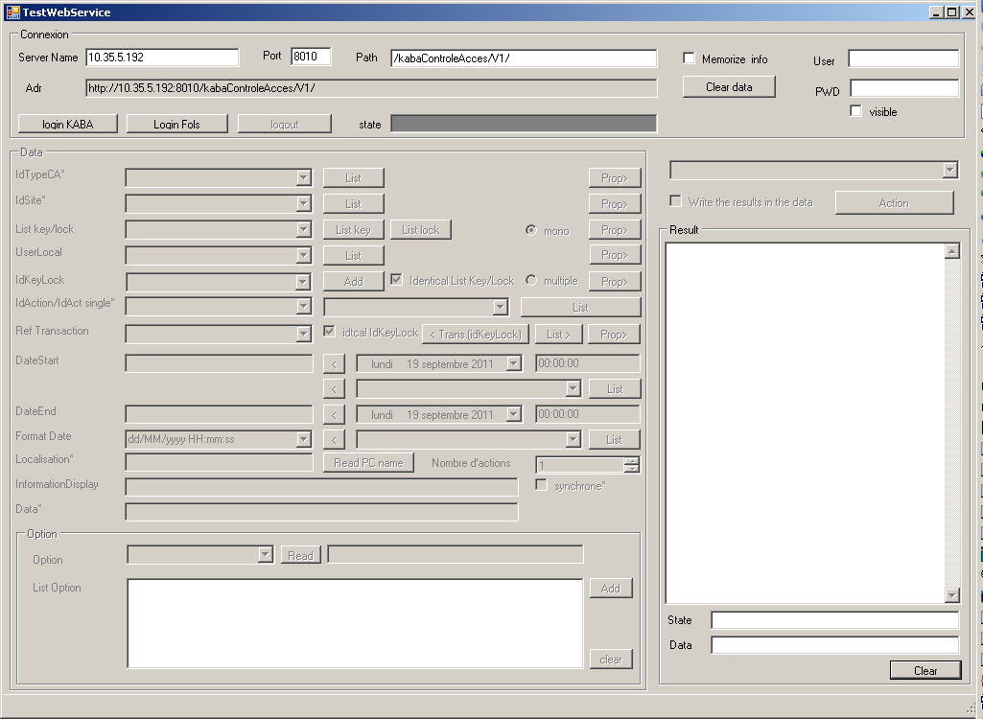

- Enter the IP address of the machine or was filed on WebService Kaba and port configuration of Web service.
Click on "Login Kaba"

The test application provides information on the process to operate​​:
- Click on the "List" on the line referenced "IdTypeCA": list all installed access control in the web service. In our case, three access controls are available:
  - EAC for a lock code: Oracod, Codacod, Codell, Clavotel, 610, 660 EFKMW)
  - EACE for locks Oracod Expert (but by default the code calculation through EAC are automatically send to the server Oracod Expert)
  - EACCRD locks for a Map: 710, 760, 790
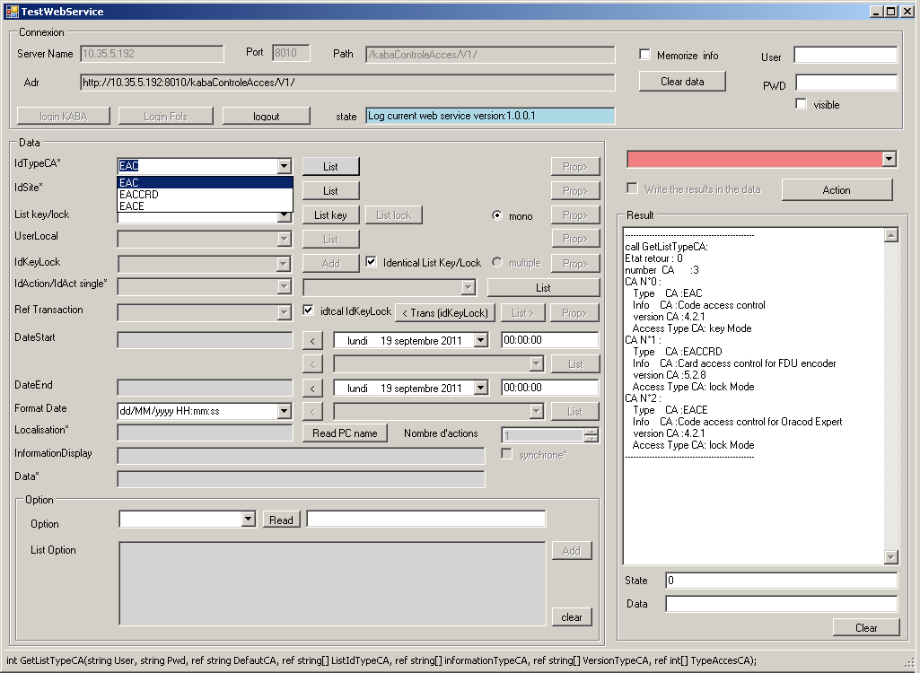
Once you select the type of access control:
- Please select one of the possible functions of the access control.
The test software will show you when they are required fields. Red in the required fields, green fields optional.

- The field list button IdSite GetListSite call and depends on the field IdTypeCA
- The Field List button list Key / Lock GetListKey call and depends on the fields and IdTypeCA IdSite
- The field list button IDactis GetListAction call and depends fields IdTypeCA, IdSite and "List Key / Lock"
- The button "Trans IdKeyLock" call the function and depends fields GetListTransaction IdTypeCA, and IdSite IdKeyLock.

All access controls do not provide all these functions. EACCRD example (for the encoder card) does not provide functions GetListSite, and GetListKey GetListTransaction.

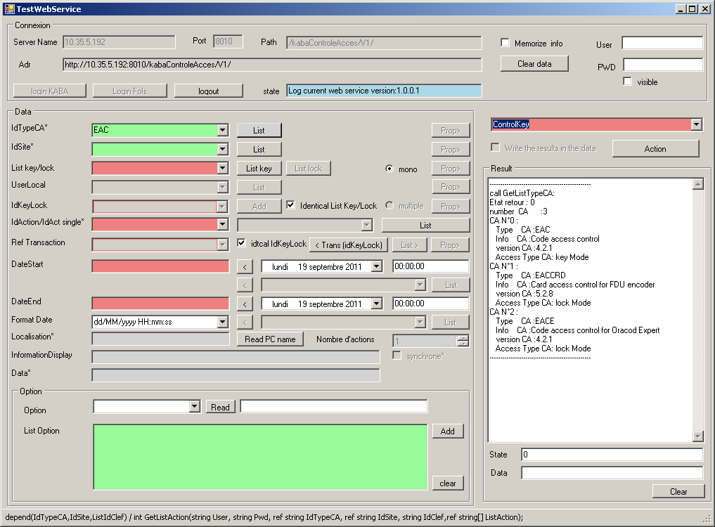
The "List Key / Lock" is not a field of the API. This is a ListBox with a list of keys (If the access control provides) Button "ListKey" call function GetListLock API and completed the ListBox.
The fields "IdKeyLock" and "RefTransaction" are parameters of the API controlKey.
If you checked "List Identical Key / Lock" the "IdKeyLock" takes the same value as what is selected in the ListBox "List Key / Lock"
If you checked "idtcal IdKeyLock" The Fields "RefTransaction" takes the same value as the "IdKeyLock".

The button "Trans IdKeyLock" GetListTransaction call the function and there is a transaction reference on the key provided (IdKeyLock). So it is displayed in the "Transaction Ref." The checkbox "IdKeyLock" is de-committed.

The "<" button behind dateStart and EndDate to enter into the fields and EndDate dateStart the date and time in the date format provided by the "FormatDate".

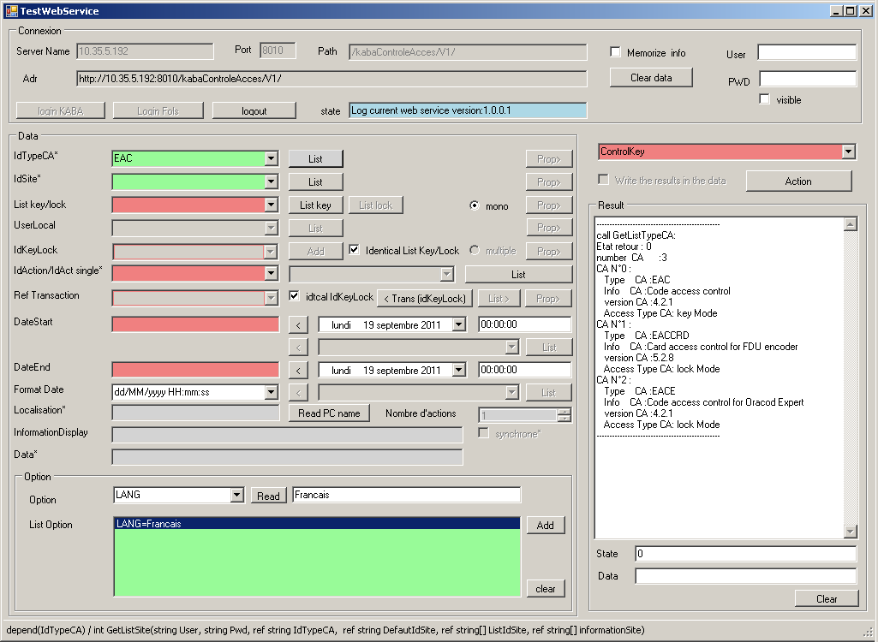
The button "add" adds a line that corresponds to "Option" = "option of Data"
These data will be added to the parameter "Option" and "DataOption" API controlKey.

For information: the "FormatData" is automatically added when calling the function controlKey with data from the field "Date format"

Once all the fields filled in:
- you are inviting controlKey call the function by clicking on the "Action"

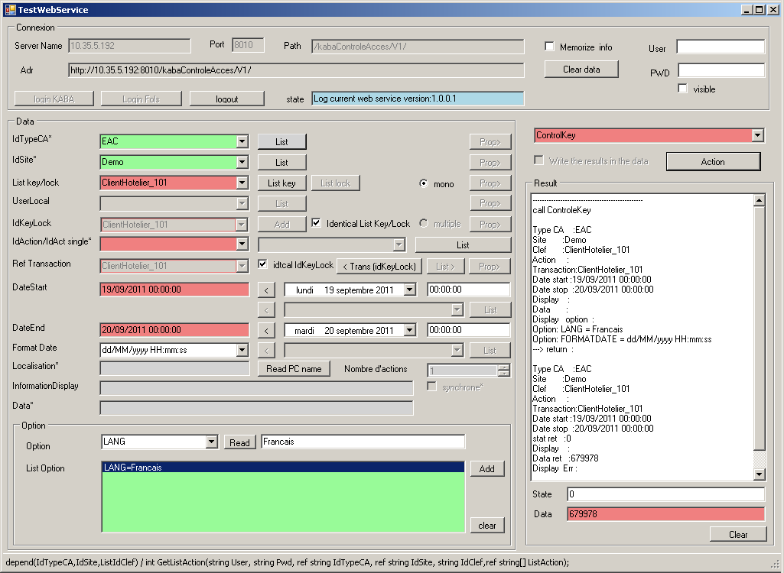

Find yourself in the TextBox "Result" all the parameters sent to the WebService Kaba and all the fields returned by it.

